**[Use Cases (Iteration 2)](https://github.com/TrinadhM-dev/GDPProject-02/wiki/Use-Cases" \l "use-cases-iteration-2)**

**What Users Aim to Achieve**:  
Users have specific objectives when interacting with the chatbot. For example, students seek course-related information, while administrative staff intend to streamline and automate various tasks.  
**User Inputs to the System**:  
Users primarily engage with the chatbot through text-based messages, where they input their questions, concerns, or requests. For instance, students may inquire about course schedules, admission requirements, or other relevant details.  
**System's Processing of User Input**:  
The chatbot's role is to effectively process user input. To accomplish this, it leverages Natural Language Processing (NLP) techniques, encompassing tasks like intent recognition. This empowers the chatbot to understand the context and intent behind the users' questions.  
**Expected User Output**:  
Users anticipate the chatbot to provide informative, accurate, and timely responses. For students, this translates to receiving precise details about courses, deadlines, and other pertinent information. The chatbot will fetch the related responses from the data.json file. Ultimately, users expect the chatbot to promptly address their inquiries and deliver helpful solutions.  
**Developer's Role**:  
Developers enhance the chatbot's capabilities by adding new intents, focusing on common user inquiries, and questions. This continual improvement ensures the chatbot can effectively understand and respond to a broader range of user inputs.

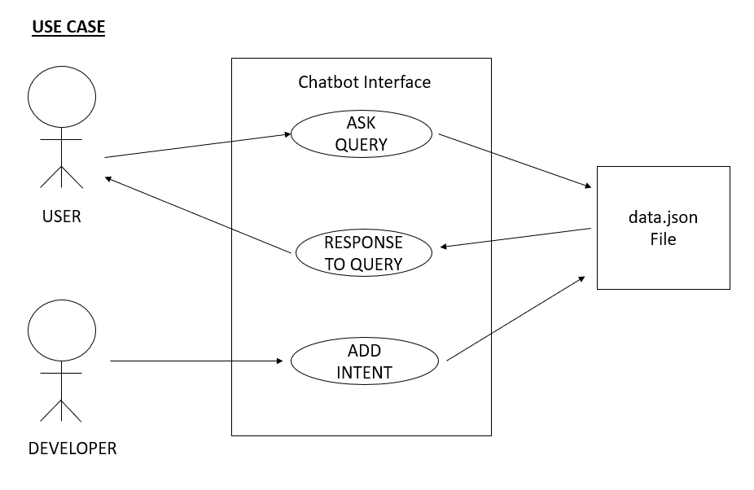

Wiki page link for Use cases (Iteration 2):

<https://github.com/TrinadhM-dev/GDPProject-02/wiki/Use-Cases#use-cases-iteration-2>